New Year’s Eve
Celebration Zone
2025

31 December 2025
Social Story
My adventure on New Year’s Eve

This book belongs to

___________________
I am going to the city to have fun at the New Year’s Eve Celebration Zone.
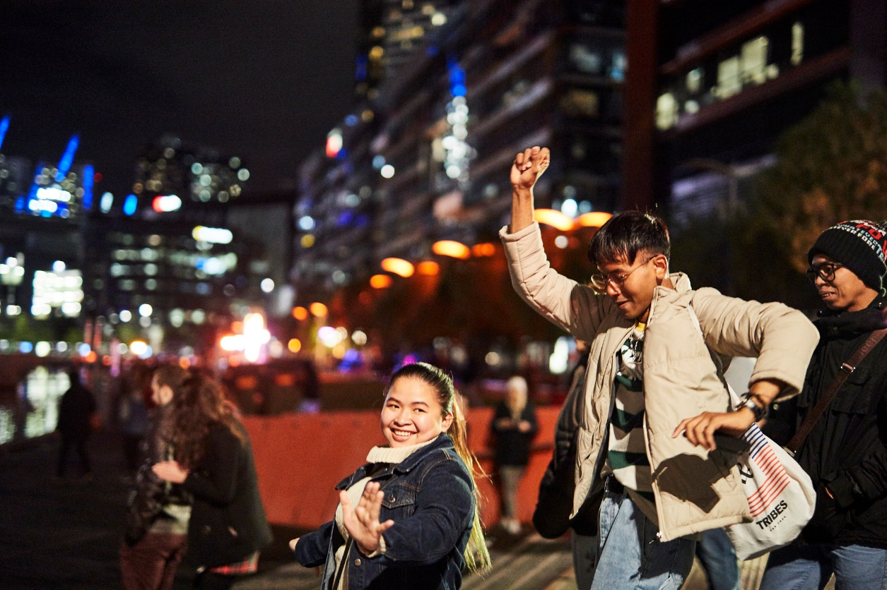
It will be dark outside.
There will be lots of people
and noisy places.

But there will be quieter places too.
I will be able to sing and dance to music.

I might see bright coloured lasers in the sky.

There will be fireworks. Fireworks make loud noises and coloured patterns in the sky.

Fireworks are fun, but they make loud bangs and can be scary.

We are safe when we stand away from fireworks and listen to instructions.

There will be yummy food to buy…

Or I can eat food I bring from home. 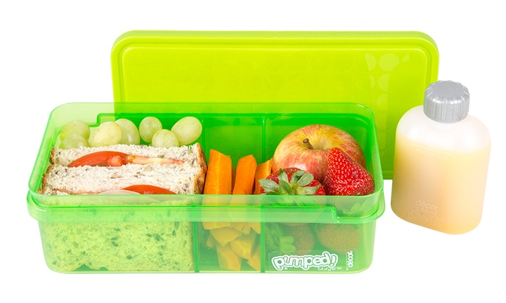
If I need the toilet, (there will be signs) and I can also let my family/ friends/ companions know and they will help me.
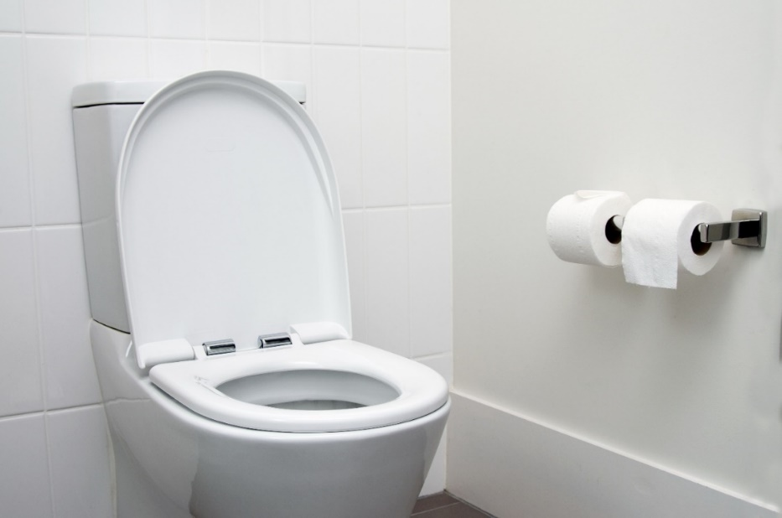

There will be a map for each Celebration Zone showing the amenities.

If I need help, I can talk to Event Staff. They are wearing pink Hi-Viz vests and Sunflower Badges.

